Sample Paper – 2013
Class – X
Subject – Mathematics
Time: 3 hours Maximum marks: 90
- All questions are compulsory.
- The question paper consists of 34 questions divided into 4 sections, A, B, C, D Section-A comprises of 8 questions of 1 mark each. Section-B comprises of 6 questions of 2 marks each. Section-C comprises of 10 questions of 3 marks each and Section D; comprises of 10 questions of 4 marks each.
- Question numbers 1 to 8 in Section-A are multiple choice questions where you select one correct option out of the given four.
- There is no overall choice. However, internal choice has been provided in 1 question two marks, 3 questions of three marks each and 2 questions of four marks each have to attempt only one of the alternatives in all such questions.
- Use of calculators is not permitted.
Section - A
Question numbers 1 to 8 carry 1 mark each. For each question, four alternative choices have been provided of which only one is correct. You have to select the correct choice.

- Which of the following will have a terminating decimal expansion?
  - 77 / 210
  - 23 / 330
  - 125 /441
  - 57 / 8
- If (x + 1) is a factor of x² - 3ax + 3a - 7, then the value of a is
  - 1
  - -1
  - 0
  - 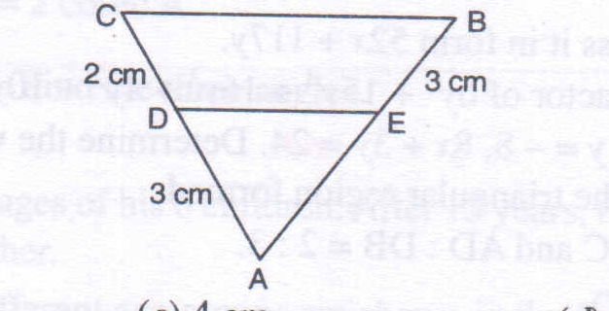-2
- In the adjoining figure, DE // CB. What is the length of AE ?
  - 5
  - 4.5
  - 4
  - 3
- If θ is an acute angle and cos θ = 9 / 41, then the value of tan θ is
  - 40 /41
  - 9 / 40
  - 40 / 9
  - 9 / 41
- 9 sec² A - 9 tan² A is equal to
  - 0
  - 1
  - 9
  - -9
- The class mark of a class interval is equal to
  - lower limit + upper limit
  - upper limit -lower limit
  - 2 (upper limit -lower limit)
  - 2 (upper limit + lower limit)
- The value of sin² 5° + sin² 10° + sin²15° + ... + sin²90° is equal to
  - 8
  - 8.5
  - 9
  - 9.5
- If 0 < θ < 90°, then sec θ is
  - >1
  - <1
  - =1
  - 0
SECTION-B
Question number 9 to 14 carry 2 marks each.
- If sec 4A = cosec (A - 20°) where 4A is an acute angle, find the value of A.
- Write the following distribution as more than type cumulative frequency distribution:
Class interval | 50-55 | 55-60 | 60-65 | 65-70 | 70-75 | 75-80
Frequency | 2 | 6 | 8 | 14 | 15 | 5
- Two poles of height 10 m and 15 m stand vertically on a plane ground. If the distance between their feet is 5√3 m, find the distance between their tops.
- Use Euclid's division algorithm to find H.C.F. of 870 and 225.
- α, β are the roots of the quadratic polynomial P(x) = x ² - (k + 6)x + 2(2k -1). Find the value of k, if α + β = ½ αβ
- Solve: 37x + 43y = 123, 43x + 37y = 117.
OR
Solve: 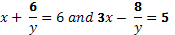
SECTION-C
Question number 15 to 24 carry 3 marks each.
- Find the LCM and HCF of 510 and 92 and verify that LCM x HCF = product of the two numbers.
Or
Find the HCF of 52 and 117 and express it in form 52x + 117y.
- Using division show that 3y² + 5 is a factor of 6y⁵ + 15y⁴ + 16y³ + 4y² + 10y - 35.
- 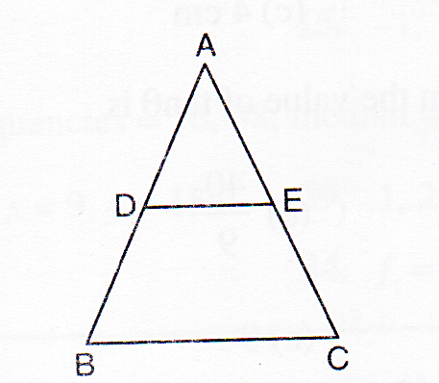Draw the graphs of the equations 2x - y = - 8, 8x + 3y = 24. Determine the vertices of the triangle by the lines representing these equations and the x-axis. Shade the triangular region formed.
- In the given figure, DE is parallel to BC and AD: DB = 2: 3. Determine area (∆ADE) : area (∆ABC).
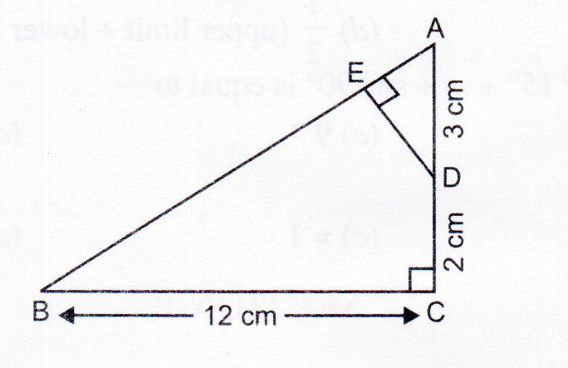Or
In the given figure, ABC is a right-angled triangle at C. Prove that ∆ABC ∆ADE and find the lengths of AE and DE.

- If cos A = .12 /13, then verify that sin A(l - tan A) = 35 /156
- ABC is a triangle and PQ is a straight line meeting AB in P and AC in Q. If AP = 1 cm, PB = 3 cm, AQ = 1.5 cm, QC = 4.5 cm. Prove that area of MPQ is one-sixteenth of the area of ∆\ ABC.
- Evaluate: cot θ. tan (90° - θ) - sec (90° - θ) cosec θ + sin² 25° + sin² 65° + √3 tan 6° tan 16° tan 74° tan 84°.
Or
Show that: (tan A + cosec B)² - (cot B - sec A)²= 2 tan A cot B (cosec A + sec B).
- Calculate the median for the following data:
Class | 20-40 | 40-60 | 60-80 | 80-100 | 100-120 | 120-140 | 140-160
Frequency | 12 | 15 | 23 | 18 | 12 | 12 | 8
- The ages of employees in two factories A and B are given below:
Age of Employees  (in Years) |  | 20-30 | 30-40 | 40-50 | 50-60 | 60-70
Number of Employees  in Factories | A | 5 | 26 | 78 | 104 | 98
 | B | 8 | 40 | 58 | 90 | 83
Find the modal age of employees in factory A and factory B.
- Prove that 5 + √2 is an irrational number.
SECTION-D
Question number 25 to 34 carry 4 marks each.
- Prove that : 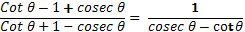
OR
Prove that: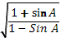 = sec A + tan A
- If tan θ + sin θ = m and tan θ – sin θ = n, show that (m ² - n²)² = 16mn
- Find the mean of following distribution by step deviation method.
Daily Expenditure | 100-150 | 150-200 | 200-250 | 250-300 | 300-350
No. of householders | 4 | 5 | 12 | 2 | 2
- Draw 'less than Ogive' for the following frequency distribution and hence obtain the median.
Marks obtained | 10-20 | 20-30 | 30-40 | 40-50 | 50-60 | 60-70 | 70-80
No. of students | 3 | 4 | 3 | 3 | 4 | 7 | 9
- Prove that the ratio of the areas of two similar triangles is equal to the square of the ratio of their corresponding sides.
OR
Prove that in a triangle, if square of one side is equal to the sum of the squares of the other two sides, then the angle opposite the first side is a right angle.
- Nine times a two-digit number is the same as twice the number obtained by interchanging the digits of the number. If one digit of the number exceeds the other number by 7, find the number.
- Solve the following system of equations graphically and find the vertices of the triangle formed by these lines and the x-axis.
4x - 3y + 4 = 0, 4x + 3y - 20 = 0
- Find all the zeroes of the polynomial x ⁴ - 5x ³ + 2x ² + 10x - 8, if two of its zeroes are √2,-√2.
- Use Euclid's division lemma to show that the square of any positive integer is either of the form 3 m or 3m + 1 for some integer m.
- In a ∆ABC, the angles at B and C are acute. If BE and CF are drawn perpendicular on AC and AB respectively, prove that: BC ² = AB x BF + AC x CE

Paper Submitted By:
Name Rahul Varshneyss
Email rahulpcm201@rediffmail.com
Phone No. 9759979695

